WVARA Field Day, 21-23 June 2013
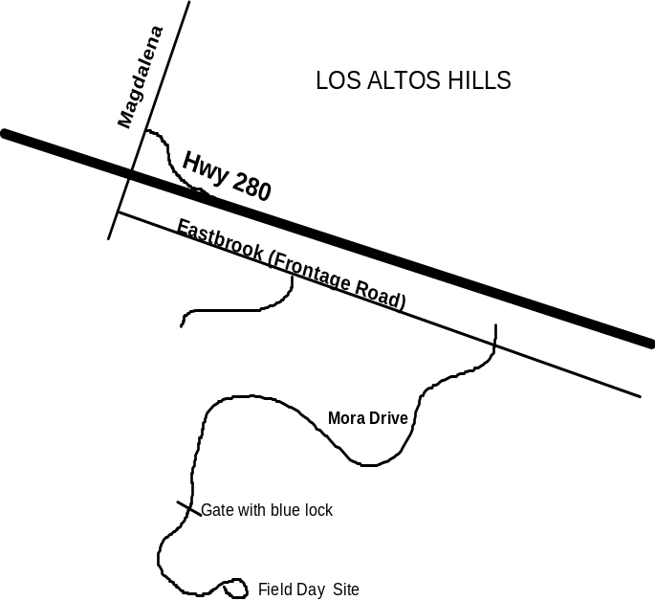

How can I participate?
- Join us for set-up, beginning Friday at 8am
- Come operate Saturday 11am to Sunday 11am (HF/SSB, HF/CW, HF/Digital, VHF/UHF, GOTA
- Bring kids/friends/non-hams for the GOTA station
- Help us with tear-down beginning 11am on Sunday
Locked Gate
- Bring a camera and record our adventure!

WHERE: This year’s Field Day operation will be at the top of Mora Hill (see map above) located in the San Antonio Open Space Reserve near the Madgellena exit off of Highway 280 in Los Altos Hills.

WHEN: Set up of the tents, antennas and equipment will begin at 8am on Friday June 21. Please come Friday morning if possible – we’ll need all the help we can get! Our plan is to be completely set up by evening so that we can do some recreational operating and test out the antennas Friday night. Several of us expect to spend Friday night on Mora Hill.

Final set-up activities will occur Saturday morning. Field Day operations officially begin Saturday at 11am and continue until 11am Sunday. Our goal is to keep all of the HF stations in operation the full 24 hours. Tear-down and packing activities will probably last from 11am until about 2pm Sunday afternoon. What to bring: 1) hot weather gear (straw hat, sun screen, sun glasses, 2) sturdy shoes, 3) sweater or warm coat for late night, and 4) a camera or camcorder!

If you are interested doing some radio operating on Mora Hill, please log onto the following URL and complete a brief survey so that we can include you in our plans:
http://www.surveymonkey.com/s/NHGQB8Z

Questions? Contact Jim Peterson, K6EI
408 490-1885 or via email at
CQFieldDay@gmail.com
Parking at the Field Day site is limited. As a result, we are limiting the vehicles parked at the site to individuals who bringing heavy equipment or with physical limitations. For the rest, we recommend parking down the hill on the surface street locations shown on the map. Note: Do not park within 300 feet of the gate. There are “no parking” signs in that area and they do write parking tickets. Note that there is usually plenty of parking along Kenbar and Rolly Drive.

Suggesting Parking Locations


